Capstone International Center hosted Study Abroad Fair
By Chelsea Gray
TUSCALOOSA, Ala. - The Capstone International Center hosted a study abroad fair on Sept. 18 in the Crimson Promenade to showcase the different study abroad opportunities available to all UA students to both further broaden their knowledge while simultaneously providing them the opportunity to explore a new country.
"Studying abroad in Italy really gave me an outside perspective on how differently other countries handle social problems and situations compared to America," said Matthew Rights, a civil engineering major at UA.
At the fair, there were as many as 20 booths set up in the Crimson Promenade where students could talk to each booth's representatives about what their specific program had to offer.
The Capstone International Center offers’ students many different services. One of the services is the support needed to jump-start student’s international studies careers.
"Studying abroad has made many different impacts on a lot of students' lives," said Tanja Jones, the associate professor of art history, Renaissance, and baroque director. "One of the most significant impacts the program has provided for students is giving them the opportunity to travel and make memorable memories that they will cherish forever."
UA offers five different types of programs for studying abroad. Faculty-led, exchange, affiliated, and direct enrollment are the five options students can choose from.
The program's goal is not only to expand students' knowledge but also to broaden their understanding of different cultures.
"I really recommend studying abroad to everyone," said Brooke Trudelle, a study abroad student at UA. "I went on a trip in June to Ireland. I got to see the geography of Ireland, and it really helped me connect with the culture."
The study abroad program is currently looking for more students to be involved in their journey.

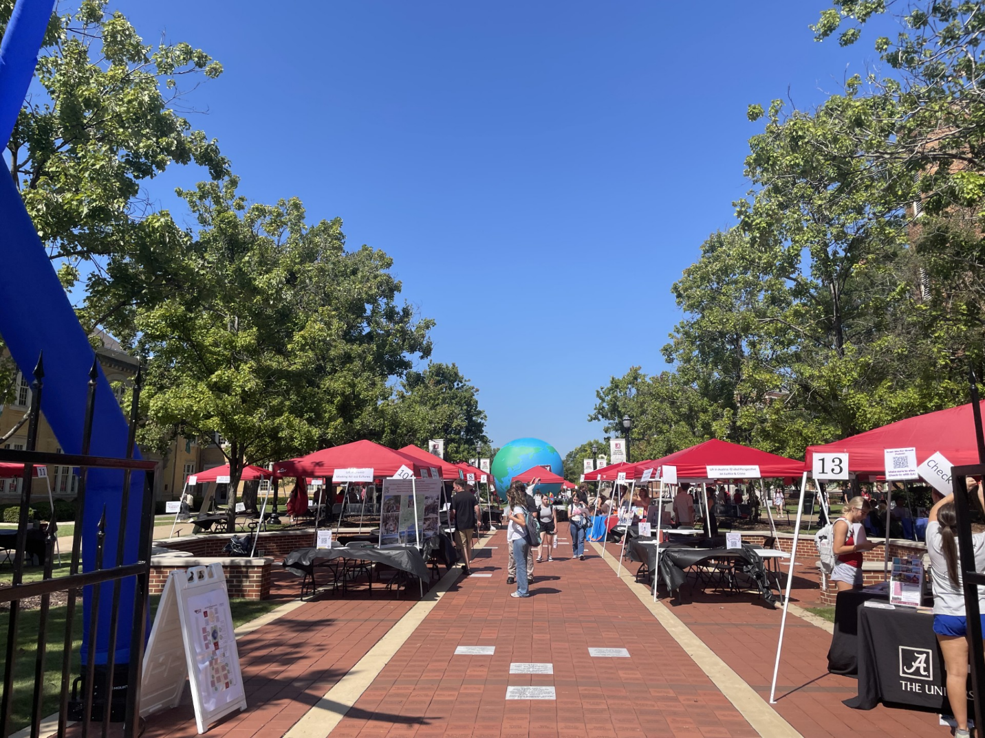

The entrance of the study abroad fair.

